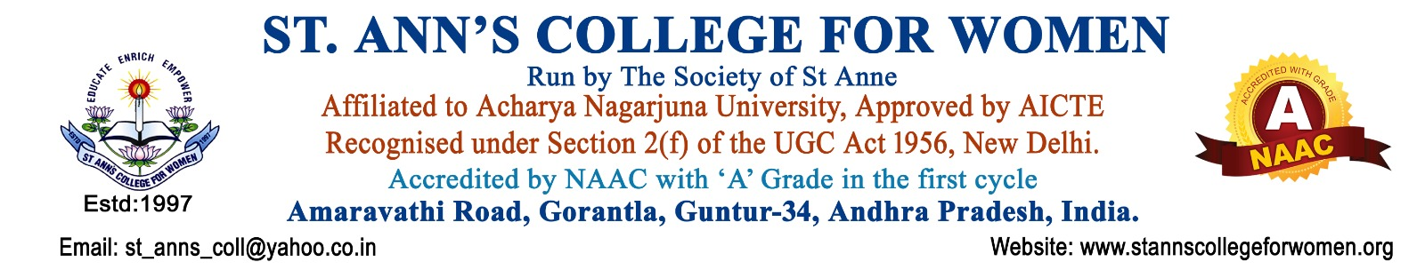

3.Anti-Drug Committee Guidelines & Procedures
1. Introduction
The Anti-Drug Committee of St. Ann’s College for Women, Gorantla, Guntur is constituted to create awareness about the harmful effects of drug abuse and to ensure a safe, healthy, disciplined, and drug-free campus environment. The committee functions in accordance with the guidelines and advisories issued by the University Grants Commission, National Assessment and Accreditation Council, Government of Andhra Pradesh, and other competent authorities.
The committee is committed to promoting preventive education, counseling, vigilance, and strict implementation of anti-drug regulations within the institution.
2. Objectives
The Anti-Drug Committee aims to:
- Create awareness among students and staff regarding the harmful effects of drug abuse and substance addiction.
- Promote a drug-free campus environment through preventive and educational measures.
- Conduct awareness campaigns, seminars, workshops, rallies, poster presentations, and pledge activities.
- Monitor and report any suspicious activities related to drug usage or substance abuse within the campus.
- Provide counseling, guidance, and support to affected students whenever necessary.
- Ensure strict implementation of anti-drug policies and government regulations.
- Maintain discipline and take appropriate action against violations related to drug abuse.
- Encourage students to adopt healthy lifestyles and positive values.
3. Constitution of the Committee
The Anti-Drug Committee shall consist of:
- Principal – Chairperson
- Anti-Drug Committee Coordinator – Convener
- IQAC Coordinator
- Faculty Representatives
- Student Representatives
- NSS Coordinator
- Counselor / Mentor (if available)
- Administrative Staff (if required)
4. Roles and Responsibilities
Chairperson
- Provide overall guidance for anti-drug initiatives.
- Ensure implementation of anti-drug policies and government regulations.
- Review committee activities periodically.
Committee Coordinator
- Coordinate awareness programs and committee activities.
- Organize meetings, campaigns, and preventive initiatives.
- Maintain reports and documentation of activities.
IQAC Coordinator
- Integrate anti-drug awareness activities with institutional quality initiatives.
- Support documentation required for NAAC purposes.
Faculty Members
- Monitor student behavior and identify concerns if any.
- Encourage students to participate in awareness activities.
- Guide students towards healthy and disciplined practices.
Student Representatives
- Assist in organizing awareness campaigns and pledge activities.
- Promote anti-drug messages among students.
- Report concerns or suspicious activities responsibly.
NSS Coordinator
- Organize outreach activities and awareness campaigns in collaboration with NSS.
- Promote community awareness regarding drug abuse prevention.
Counselor / Mentor
- Provide counseling and emotional support to affected students.
- Guide students towards rehabilitation and positive behavioral changes if required.
Administrative Staff
- Assist in maintaining records, reports, and communication related to committee activities.
5. Guidelines & Procedures
5.1 Awareness Programs
The committee shall organize:
- Awareness Seminars
- Workshops
- Guest Lectures
- Poster Presentations
- Rallies and Campaigns
- Pledge Programs
- Awareness Videos and Exhibitions
to educate students about the harmful effects of drugs and substance abuse.
5.2 Preventive Measures
- Display anti-drug awareness posters and signboards on campus.
- Promote a healthy and disciplined campus culture.
- Encourage participation in sports, cultural, and wellness activities.
- Conduct orientation programs for newly admitted students.
5.3 Monitoring & Vigilance
- Monitor campus environment to prevent drug-related activities.
- Report suspicious behavior or activities to the concerned authorities.
- Maintain confidentiality while handling sensitive matters.
5.4 Counseling & Student Support
- Provide counseling support to affected students whenever necessary.
- Encourage students to seek help without fear or stigma.
- Refer serious cases to professional counselors or authorities if required.
5.5 Disciplinary Measures
- Strict disciplinary action shall be taken against students involved in drug abuse, possession, distribution, or related activities within the campus.
- Actions shall be taken as per institutional rules, UGC regulations, and Government guidelines.
- Serious violations may be reported to law enforcement authorities whenever necessary.
5.6 Responsibilities of the Anti-Drug Committee
The committee shall:
- Ensure a safe and drug-free campus environment.
- Promote preventive education and awareness.
- Encourage student participation in anti-drug initiatives.
- Maintain proper records and documentation of activities.
- Coordinate with institutional authorities and external agencies whenever required.
- Support students through counseling and guidance services.
6. Documentation
The committee shall maintain:
- Committee Meeting Minutes
- Awareness Program Reports
- Attendance Registers
- Photographs and Posters
- Circulars and Notices
- Counseling Records (if applicable)
- Activity Documentation for NAAC
7. Role in NAAC & Institutional Development
The Anti-Drug Committee contributes towards:
- Student Welfare and Discipline
- Institutional Values and Social Responsibility
- Holistic Student Development
- Healthy Campus Environment
- Extension and Awareness Activities
- Quality Enhancement Initiatives
8. Monitoring & Review
- The functioning of the committee shall be reviewed periodically by the Principal and IQAC.
- Feedback from students and staff shall be considered for improving anti-drug awareness and preventive measures.
9. Expected Outcomes
- Increased awareness about the harmful effects of drug abuse.
- Development of a safe, disciplined, and healthy campus environment.
- Reduction in substance abuse-related risks among students.
- Enhanced student well-being and responsible behavior.
- Strengthened institutional commitment towards social responsibility and student welfare.
10. Conclusion
The Anti-Drug Committee of St. Ann’s College for Women, Gorantla, Guntur is committed to maintaining a safe, disciplined, healthy, and drug-free campus through awareness, prevention, counseling, monitoring, and strict implementation of anti-drug regulations in accordance with UGC, NAAC, and Government of Andhra Pradesh guidelines.

